PROJECT REPORT TEMPLATE

1.INTRODUTION

* 1. Overview

Zoho books is a cloud-based accounting software

That can help manage finances and accounting for businesses like keerthi sweets.It can be used for tasks such as invoicing, expense tracking ,inventory management ,and more.

1.My project title was “preparation and maintainence for keerthi sweets in ZOHO books.

2.My project duration was 28 days.I finished my projects in 2 days after the starting day.

* 1. purpose

1. Accounts maintained easily.
2. Time saving.
3. It is an easy way to create sales,purchase order,bills

and invoices.

2.probleam definition and design thinking:

2.1 Empathy map

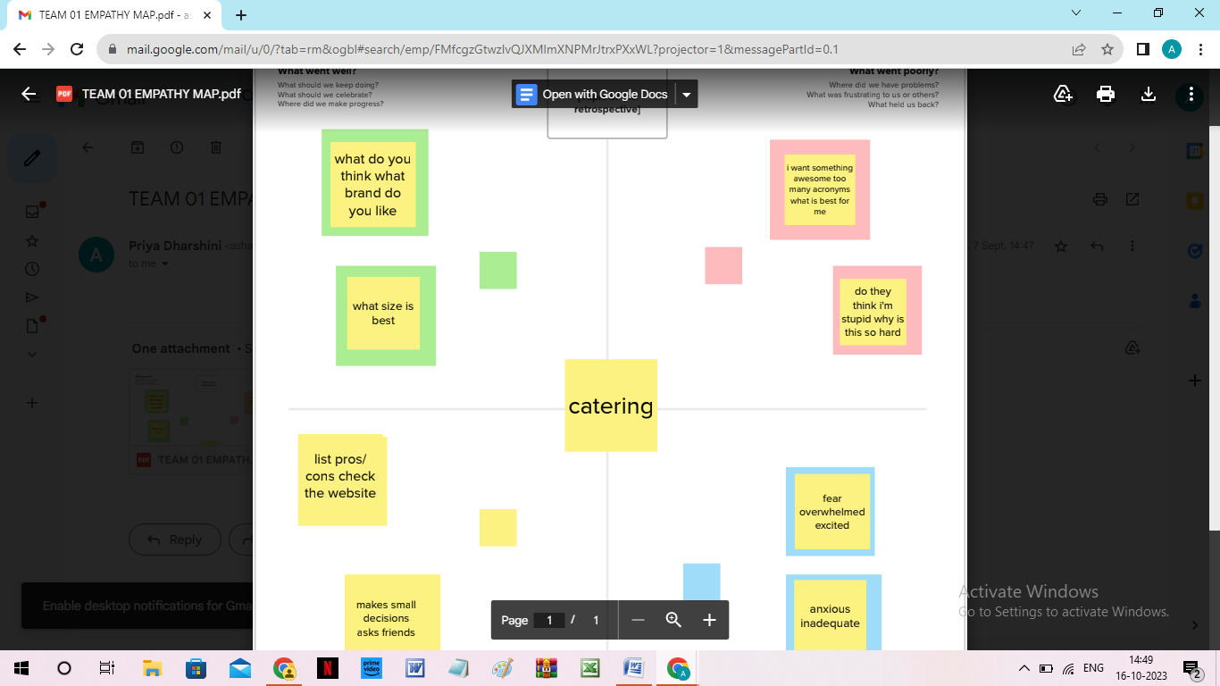

2.2 Idea and brainstorming map

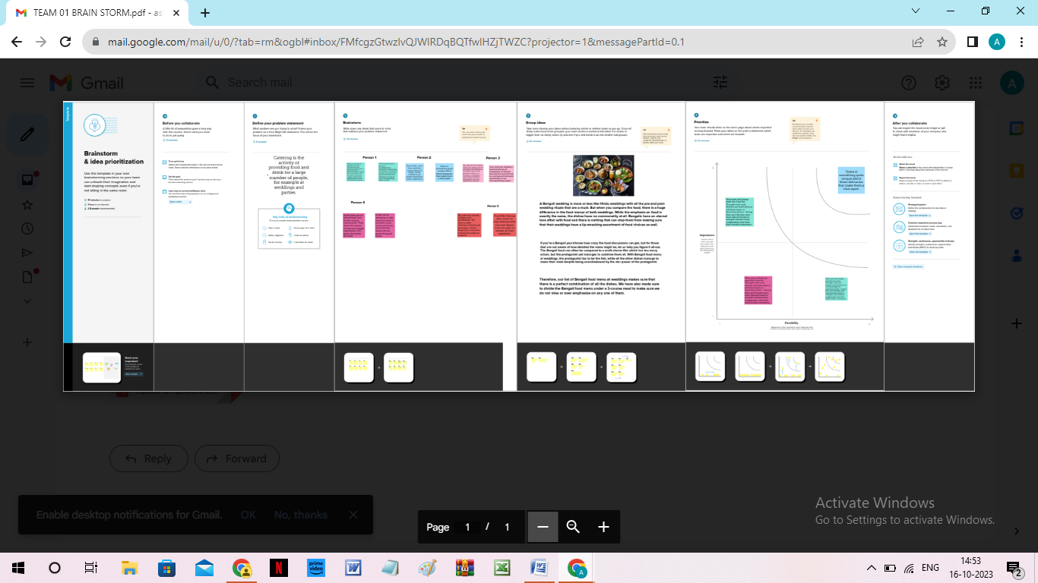

3.Result

In the result,I can find out profit and loss and balance sheet report.

PROFIT AND LOSS OUTPUT

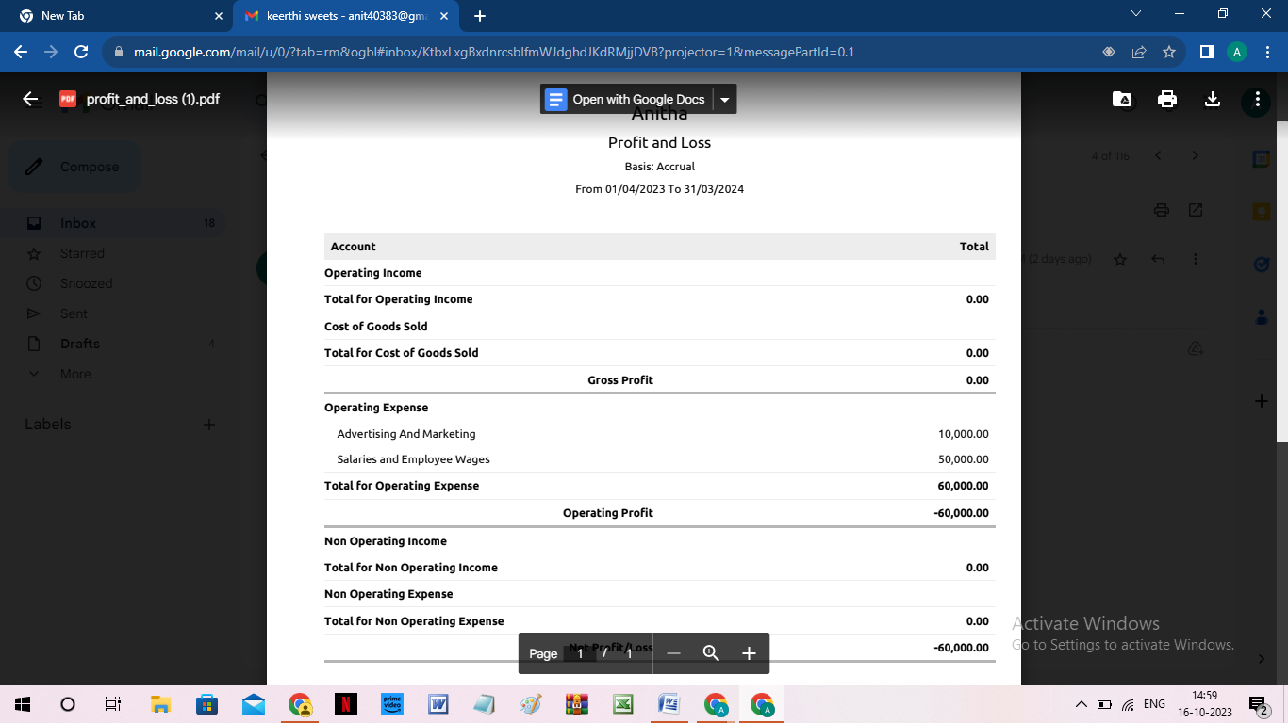

BALANCE SHEET

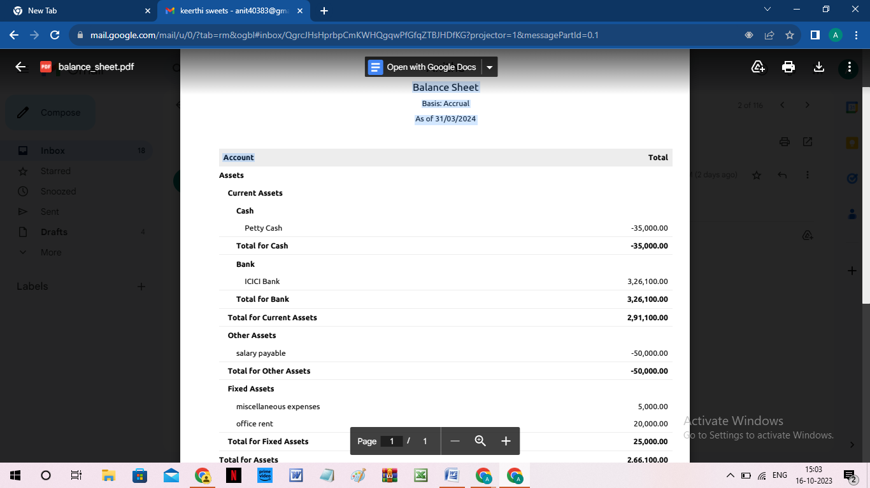

1. Advantage and dis advantage

Advantages:

1.Accounts maintained easily.

2.Time saving.

3.It is an eeasy to create sales ,purchase

Order,bill and invoices.

Disadvantages:

1.we cannot see the customers and to talk over the customers.

5.Applications:

Zoho books link:books.zoho.com

6.conclusion:

1.first we open the link and we create the organization name .

2.the zoho books page opened,first we create the items.

3.then ,sales creation and purchase creation.

4.now to create vendors,purchase order,bills and invoices,customers,adding bank account,new accounts and ledger,journal entries,recording banking transactions.

5.to see the reports wht we can created and recorded.

7.future scope:

1. group scope provided complete access to all functions the user can perform on the record.

2.for instance,a group scope can allow a user to read,create update and delete records in all modules.

3.the user has access to all modules in the client zohoCRM account.

8.appendix:

A.source code:

1.empathy map and brainstorm link: